**COMSATS University Islamabad,   
Park Road, Chak Shahzad, Islamabad Pakistan**

Project Proposal   
(SCOPE DOCUMENT)

for

**Comfort Zone**  
Version 1.0

***By***

**Muhammad Osama CIIT/FA16-BSE-088/ISB**

**Rana Waqar Tufail CIIT/FA16-BSE-117/ISB**

**Haris Mehmood CIIT/FA16-BSE-154/ISB**

***Supervisor*Mr Muzafar Iqbal**

*Bachelor of Science in Computer Science (2016-2020)*

|  |  |  |
| --- | --- | --- |
| **No.** | **Comment** | **Action** |
|  |  |  |
|  |  |  |
|  |  |  |
|  |  |  |
|  |  |  |
|  |  |  |

**SCOPE DOCUMENT REVSION HISTORY**

**Supervisor Signature**

**Date:**

# Table of Contents

1. Introduction 3

2. Problem Statement 3

3. Problem Solution for Proposed System 4

4. Related System Analysis/Literature Review 4

5. Advantages/Benefits of Proposed System 4,5

6. Scope 5

7. Modules 5

7.1 Module 1: Billing 5

7.2 Module2: tracking………………………………………………………………...........6

7.3 Module 3: Complaint 6

7.4 Module4: Facility corner……………………………………………………………….6

7.5 Module 5: advertisement corner 6

7.6 Module 6: Election 6

7.7 Module 7: Security……………………………………………………………………...6

7.8 Module 8: Tender and auction 6

7.9 Module 9: Chat forum 7

7.10 Module 10: Fund raising 7

8. System Limitations/Constraints 7

9. Software Process Methodology 7

10. Tools and Technologies 7,8

11. Project Stakeholders and Roles 8

12. Team Members Individual Tasks/Work Division 8

13. Data Gathering Approach 9

14. Concepts 9

15. Gantt chart 9

16. Mockups 10,11

17. Conclusion 12

18. References 12

19. Plaragism Report 12

**Project Category:**

** B-**Web Application/Web Application based Information System  **E-** Smartphone Application

# Abstract

# The Project is Airport Employees Housing Society Software (Website).In this society there are many things which operate manually. So this software automates these things and solves many issues which the members of society faced on daily basis. The system automates the billing system. Garbage complaint by uploading the image of the location containing waste. Tracking and monitoring of garbage trucks and water tankers. Members will able to create the emergency alter in case of any security issue by using the Security feature. The society management will able to collect the funds online. The chat and online video call facility for the interaction of the society members. The election which held in the society will also manages on the software. The system will also provide the feature of tender and automated auction management.

# Introduction

This document is for the detail overview of this Airport Housing society software. In this document all the functionalities, advantages of the Airport housing society software its uses, which tools and technologies and processes will be used are described. The main purpose of this project is to fully automate the manual operations like (billing, complaint, security alert etc.) which are running in airport housing society right now. It will facilitate the members and administration to perform their task easily. Now the members will able to get their bills online from the software and also track the garbage truck. The complaint procedure becomes reliable and active for the members.

# Problem Statement

In this digital world many affairs of airport housing society operates manually. The members of society receive their bills at their door steps manually. Many times the bill lost from their garages. This procedure of delivering bill is risky required manpower and money. Keeping in mind the current security situation the members are unable to contact the concern security officials, if they face any security hazard. The garbage spreads on the open area cause smells and pollutes the atmosphere. So there is no defining procedure of complaining the authority to dispose this garbage. The members also face the problem of how to contact and monitor the garbage truck which collects the garbage. The society faces shortage of budget for the development of new tube wells so they need fundraising from the members. The manual system of fundraising is not trustworthy. The manual tender and its auction system involve the allotment of tender to favorite contractor and it involves corruption, which should be sorted out.

# Problem Solution for Proposed System

The member of the society will be able to get and pay their bill online. To get rid of the garbage spread on the street they will upload the picture of the garbage by using complaint feature and by giving related necessary information they send the complaint to the admin portal from where it will be solved soon. The members will also able to interact with the other society member by using chat forum to discuss their issue and the administration will address their issue by using this forum. The members will also able to track the garbage truck and monitor the water tanker by using the tracking and monitor feature on the software. The society election will also manage on the software the result of the election display on the software to remove any conflict between the candidates. The facility corner feature will enable the different workers like electrician, plumber etc. To publish their services on the software so the members will get their services when required. The automated tender and auction management system will make the auction procedure transparent. The admin can place the tender and after getting request within mention deadline, open it for auction. The buyer have specific time period to bid online after which the auction closes. Then the highest bid will awarded with tender.

# Related System Analysis/Literature Review

Table 1Related System Analysis with proposed project solution

|  |  |  |
| --- | --- | --- |
| **Application Name** | **Weakness** | **Proposed Project Solution** |
| Mysocietyclub.com | * It does not provide a feature for tracking and monitoring of garbage truck. * It does not have the fundraising facility for its users | * Our system provides a feature for tracking and monitoring of garbage truck. * Our system provide the fundraising facility for its users |
| ApnaComplex.com | * It does not provide the tender and auction management * It does not have a feature of election management * It does not have the advertisement feature. | * This software provides the tender and auction management * This system have a feature of election management * This software has the advertisement feature. |

# Advantages/Benefits of Proposed System

* + Manual billing system will be fully automated.
  + Member’s time will be saved.
  + The members will complaint to management easily if they face any problem.
  + Garbage will be dispose of on regular bases.
  + Security risks will be reduced for members.
  + Members can interact with the other members and society affair management become easy.
  + Society management collects and manages funds easily.
  + Revenue will be generated by society.
  + Society Elections results will be display online which build trust of the candidate on the system.
  + The corruption will be eradicated from the society.

# Scope

This software will automate the operations which are manually performing in the society. The online billing system will facilitate the members to get their bills online easily from the software, without going to the society office. The tracking features of water tanker will help the members to track and contact the tankers easily and get rid of the water shortage problem. The complaint feature will enable the member to upload the image of the area containing waste and send it to admin portal as a complaint from where it is solved easily. The alert security feature will enables the members to get rid of any security situation they face during their stay in the society. The advertisement corner feature will enables the society management to generate revenue from the advertisement which different business stakeholders of the society posted in the advertisement corner. The conversation feature will enables the society members to interact with each other and talk about the daily happenings or personnel affairs. This software will also provide the election monitoring which makes the election results more transparent and there are fewer chances that the election becomes controversial. The system will also provide the feature of tender and automated auction management. This helps in removing corruption from the society.

# Modules

## Module 1: Billing

In the Billing section the admin will able to create a bill for the members by adding the fields like water, street lights, sanitary bill etc. and the members will able to get the bill and see his previous record of the bill.

## Module 2: Tracking

The members will able to track the garbage track at the time of it collecting garbage from different street so the members will able to submit their house trash to the truck easily.

## Module 3: Compliant

In the complaint section the members will able to upload the image of the garbage which they found on the open area or the image of the damage street light, then they send the image with the description (what is the location) or any other few lines explaining the complaint.

## Module 4: Facility corner

The workers can able to create their profile by mentioning their skills like the electricians, plumbers so the members can get their services by contacting them when required.

## Module 5: Advertisement corner

In this section the member can able to advertise their products which they want to sell or if they want to grow their business they will post the ad, for example if someone wants to sell his furniture he can post the ad of the furniture or if some has to open a new shop in civic center he will advertise his shop in the advertisement corner.

## Module 6: Election

The candidate can check their eligibility criteria for contesting the election, get the nomination form for the election, the society members can check their vote status, the election results can be displayed in the form of pie charts and graphs on the software.

## Module 7: Security

This module includes the security staff profile management, the attendance of the staff and this feature enables the members to generate security alert, when they face any security risk while their stay in the society. When the alert generated a message or phone call will ring on the nearest security staff mobile no.

## Module 8: Tender and Auction

The admin can place the tender through tender management features, then the interested candidate can apply for the tender and the bidding for the tender can take place online. The buyer have specific time period to bid online after which the auction closes. Then the highest bid will awarded tender.

## Module 9: Chat forum

The members will able to post the issue for the discussion. The other members in the forum will able to give feedback on the post in the form of comment, like and share. The chat forum will also provide the feature of live video so the administration can interact with members.

## Module 10: Fund Raising

In the fund raising, the member will able to pay online using integrated payment systems and he will be able to monitor his/her funds.

# System Limitations/Constraints

* This system is only made for a specific society. So this system is only used by the peoples living in the society.
* As this is client project so we are restricted by the requirements given by the client.

# Software Process Methodology

* We will use Object oriented approach.
* React is based on JavaScript and JavaScript uses object-oriented approach.
* This approach will make design reliable and flexible; code will become reusable.
* We have studied the Java/C++ that uses object-oriented approach. It would be easy for us to use ReactJS. As it uses nearly same methodologies some.

# Tools and Technologies

Mention all the hardware/software tools and technologies with version number which will be used in implementation of the project. Write about the APIs, language(s), SDK(s) etc. which you will use for implementation.

Example:

Table 2Tools and Technologies for Proposed Project

|  |  |  |  |
| --- | --- | --- | --- |
| **Tools**  **And**  **Technologies** | **Tools** | **Version** | **Rationale** |
| MS Visual Studio Code | 2019 | IDE |
| MongoDB | 2015 | DBMS |
| Adobe Photoshop | CSC 6 | Design Work |
| MS Word | 2015 | Documentation |
| MS Power Point | 2015 | Presentation |
| XD | CC 2019 | Mockups Creation |
| **Technology** | **Version** | **Rationale** |
| ReactJS | 16.8.6 | Web Development |
| React Native | 0.59 | App Development |
| NodeJS | 5 | Desktop Development |
|  | Express JS | 8.5.0 | Web Development |

# 

# 11. Project Stakeholders and Roles

Write down the project stakeholders and their roles.

Table 3Project Stakeholders for Proposed Project

|  |  |
| --- | --- |
| **Project Sponsor** | The sponsor of the project is Airport Employees Cooperative Housing Society Rawalpindi Administration |
| **Stakeholder** | Client:  Airport Employees Housing Society Rawalpindi Administration  Supervisor:  Mr. Muzaffar Iqbal  Developer:  Muhammad Osama  Rana Waqar Tufail  Haris Mehmood |

# Team Members Individual Tasks/Work Division

Table 4Team Member Work Division for Proposed Project

|  |  |  |
| --- | --- | --- |
| **Student Name** | **Student Registration Number** | **Responsibility/ Modules** |
| Muhammad Osama | FA16-BSE-088 | 7.3 Module 3 Complaint  7.2 Module 2 Tracking  7.5 Module 5 Advertisement corner  7.9 Module 9 Chat forum |
| Rana Waqar Tufail | FA16-BSE-117 | 7.6 Module 6 Election  7.4 Module 4 Facility Corner  7.7 Module 7 Security  7.10 Module 10 Fund Raising |
| Haris Mehmood | FA16-BSE-154 | 7.1 Module 1 Billing  7.8 Module 8 Tender and Auction  Database |

# Data Gathering Approach

As this software is for the Airport Housing Society. So we have gather information related to the software from interviewing the administration of the society, for example for the billing system. We have gather information from the clerk who is preparing bills manually in the past.

# Concepts

Algorithms: Most Algorithms will be used in modules like tracking. In security, when member generate alert, the system will automatically connect to the nearest security official.

Machine Learning: Machine Learning will be used in modules like advertisement, election, complaints.

# Gantt chart

## **F:\FYP\ComfortZone\Capture.PNG**

Figure Sample Gantt chart

# Mockups

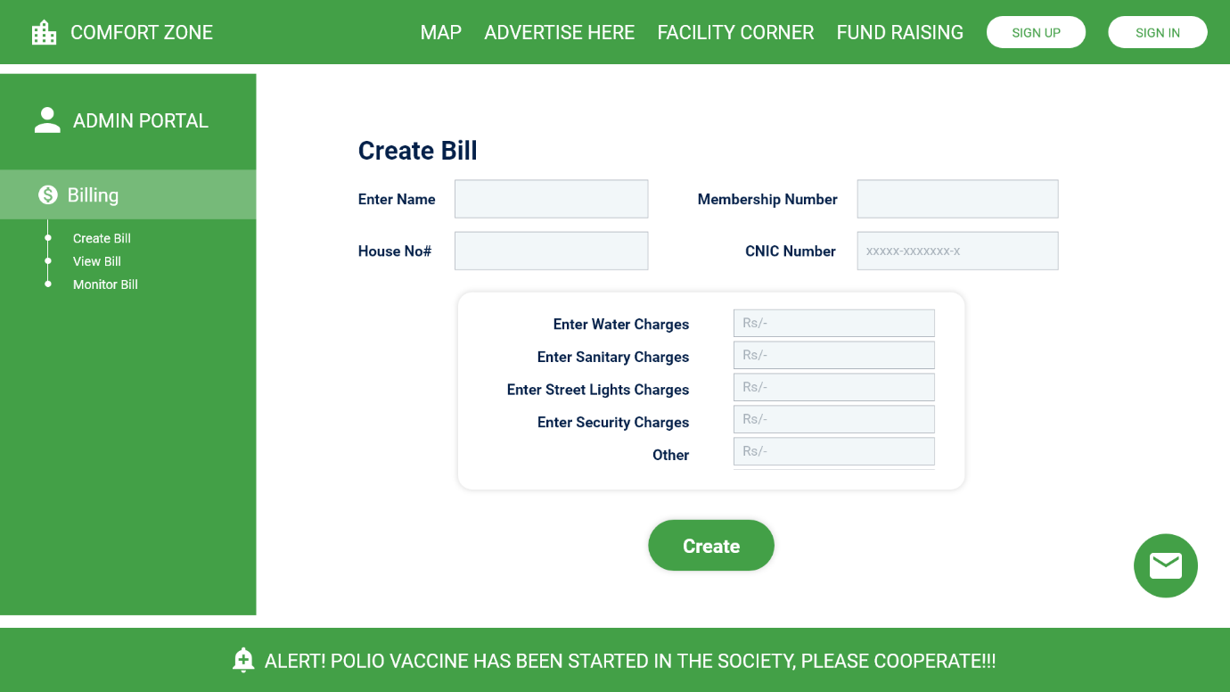

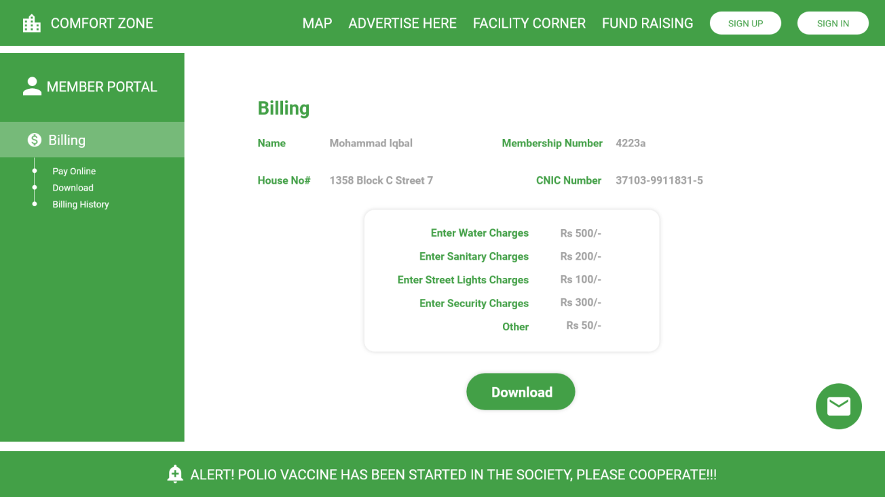

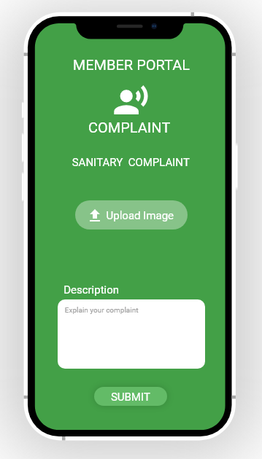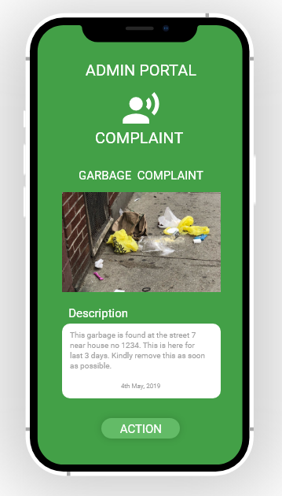

# Conclusion

In this document we have discuss the detail overview of software comfort zone that is the software for the Airport Housing society Rawalpindi. In this document all the functionalities, advantages of software its uses, which tools and technologies and processes will be used are described. The main purpose of this project is to fully automate the manual operations like (billing, complaint, security alert etc.) which are running in airport housing society right now. It will facilitate the members and administration to perform their task easily. It will also provide the features like chat forum, advertisement, complaint, security to its members.

# References

Mysocietclub.com: <https://mysocietyclub.com/>

Apnacomplex.com: <https://www.apnacomplex.com/>

# Plagiarism Report

Attach the Plagiarism report of your project scope document from library staff of turni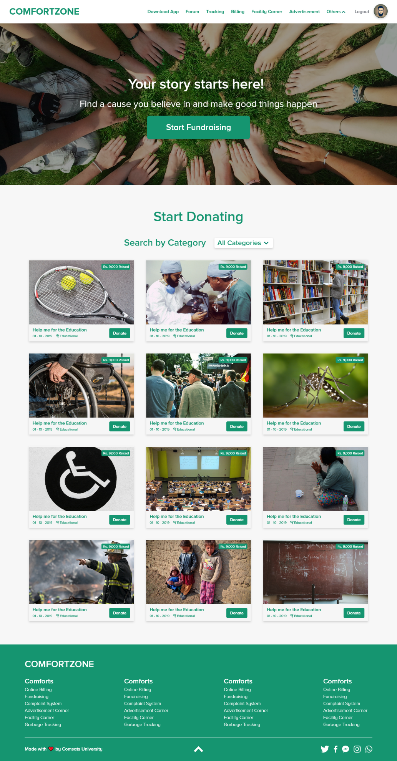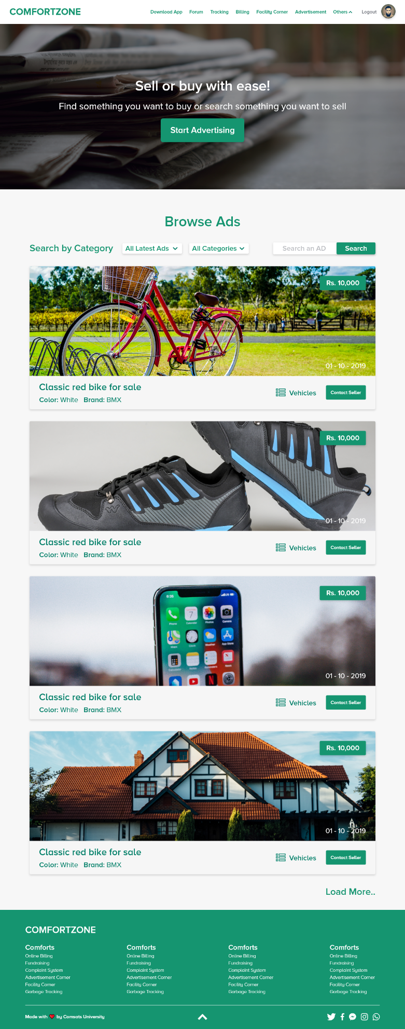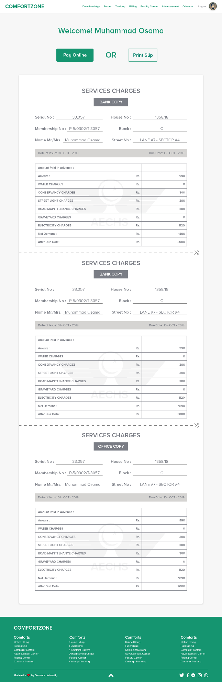tin tool (<http://turnitin.com>)